**Introduction**

The database activity module enables participants to create, maintain and search a collection of entries (i.e. records). The structure of the entries is defined by the teacher as a number of fields. Field types include checkbox, radio buttons, drop-down menu, text area, URL, picture and uploaded file.

The database is a collection of information sources on a topic or the entire course. The Teacher can set up the database activity module and assign the students to populate the content onto it. The database will function as an excellent repository of course-related information. The database entries can be almost unlimited, including text, images, websites, audios, videos and files amongst other things. The structure of the entries is defined by the teacher as a number of fields. Field types include checkbox, radio buttons, drop-down menu, text area, URL, picture and uploaded file. There are inbuilt templates for making the visual layout of the database. There is provision for linking a database entry with the words and phrases appearing in any where within the course. The teacher can grade the database entries of the students and comment on them.

**Setting up of Database Activity**

The following are the steps to set up a **Database** activity in a course.

1. Select the **Turn Editing On** button from the **gear** icon at the top right corner
2. Click the **Add an activity or resource** link and select **Database** from the Activity Chooser
3. Add a **name** and **description** for the **Database** and decide whether the description should be **display**ed **on the course page**
4. Under **Entries,** decide:
5. whether the database entries made by the students need the approval of the Teacher. If the **Approval required** is set as **Yes,** then the entries made by the students will be visible in the database only after the approval of the Teacher.
6. Whether the approved entries can be allowed to be edited by the contributing student or not by selecting **Allow editing of approved entries** as **Yes** or **No. (***Please note that this clause is relevant only if the teacher’s approval is required for making entries).*
7. Whether the Teacher and other students can comment on a student entry by selecting **Allow comments on entries** as **Yes** or **No.**
8. Whether the student has to make sufficient number of entries to the database or not in order for them to view the entries made by others by *selecting* the **None** option or by entering the number of entries under **Entries required before viewing.**(*Note that if entries are required before viewing, the database auto-linking filter should be disabled*)
9. How many entries can be made by a student to the database *under* **Maximum number of entries.**
10. Under **Availability**, decide when the Teacher wants the database to be visible to students by selecting the **Available From** and **Available To** date and time. Also, if required decide the dates the Teacher want students to be able to see entries in the database but not be able to add their own by *selecting* **Read Only From** and **Read Only To** date and time.
11. Under **Grade** decide the **Grade category** and **Grade to pass**, if any
12. Under **Ratings**, decide how the database entries should be rated and if required restrict the ratings by date and time.

**Building Database**

1. Once the settings are done for the database Activity, and clicked SAVE AND DISPLAY then the newly created Database will appear (Figure) . It is with eight sections: (1) View list (2) View single (3) Search (4) Add entry (5) Export (6) Templates (7) Fields (8) Presets

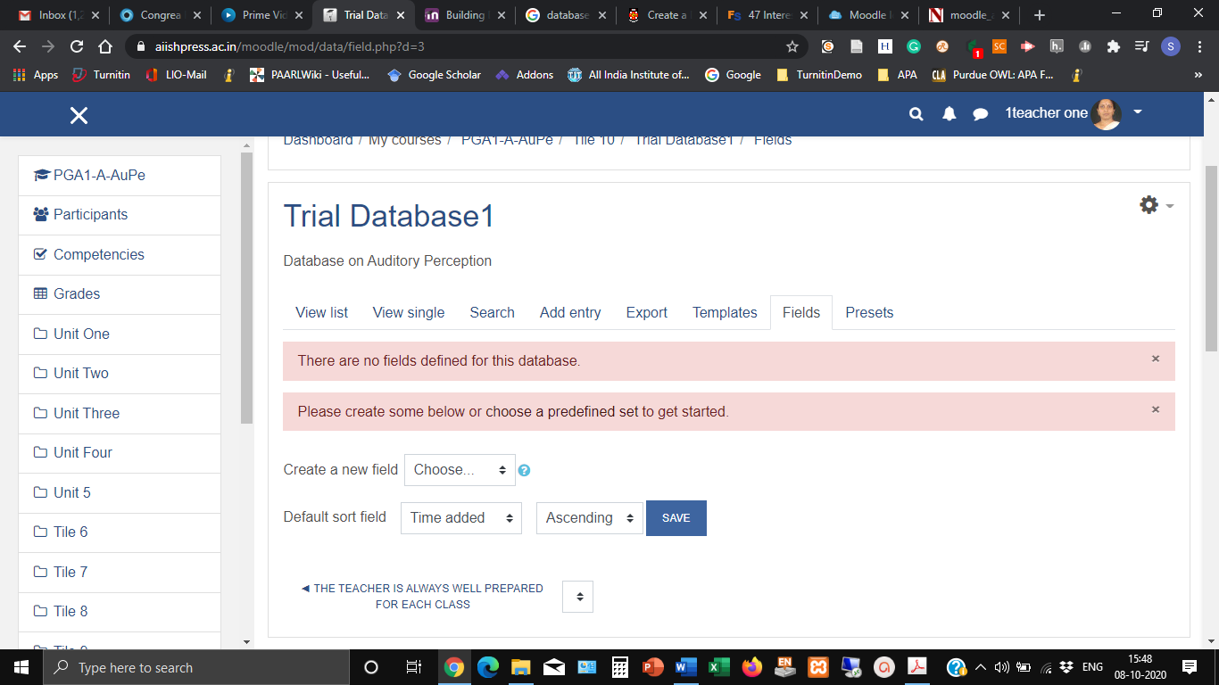

1. The first step in building the database is the selection of field type for data input. Each entry in a database activity module can have multiple fields of multiple types e.g. a book entry can have text fields for author, title etc., image field for book cover, and Date field for year of publication.

There are 12 field types, namely, Checkbox, Date, File, Latlong, Menu, Multi-menu, Number, Picture, Radio button, Text area, Text input and URL. Of these, **LatLong** is used for entering geographic location. The remaining fields are self-explanatory.

1. After selecting the required fields for the database, click on **Template** tab to decide the appearance/ view of the database. There are 8 options under **Template:** List template, Single template, Advanced search template, Add template, RSS template, CSS template and Javascript template (*By default, List template will be selected*).
2. The users can view a **single entry** or a **list of entries** of a database.
3. First click the **single template** button and the click the SAVE TEMPLATEbutton at the bottom
4. Then click the **list template** button. The list template will have a header and footer. In the header type the name of the database. Eg. Course Resource Repository and in the footer “Thanks for browsing”.
5. Click the SAVE TEMPLATE button at the bottom
6. Now, click the **Advance Search Template** and click the SAVE TEMPLATE button at the bottom
7. Next, click the **Add Template** and click the SAVE TEMPLATE button at the bottom
8. In the next step click **Add Entry** for entering the information as per the fields created

**Database Preset**

1. To avoid the necessity of always having to create a new database from scratch, the database activity module has a presets feature.